
CP&M CELL, BSNL Corporate Office,
Room No. 614, Bharat Sanchar Bhawan,
Janpath, New Delhi – 110001.

Tel: 91-11-23326021
Fax: 91-11-23351291
e-mail: ltp@bsnl.co.in

No. CP&M/ 1-2 (1)/Revenue Share/ 2013 Dated: 02.09.2013

Sub: Analysis of Circle Wise Revenue Growth along with BSNL Revenue Growth and Market Share for the Quarter ending June 2013 of F.Y. 2013-14.

- This is with reference to the Quarterly Gross Revenue figure earned by the telecom sector as published in the TRAI website for all operators. Based on the data available for the quarter ending June 2013, the detailed information at the Operator level has been compiled and is attached at Annexure-1.

- The Annexure-2 analyses the growth of the revenue on the Y-o-Y basis circle wise, for the period April-June based on the TRAI report. The data also compares the circle wise BSNL growth vis-à-vis the industry growth during this period and calculate the gaps between the two.

- The Annexure-3 analyses the growth of the revenue on the Y-o-Y basis circle wise, for the period April-June based on the TRAI report. The data compares the circle wise BSNL’s revenue growth earned by basic & Mobile Services.

- The key findings of the analysis are:

  - Total Revenue (Annexure-1):

    - BSNL revenue for the First quarter (Q1 2013-14) stood at Rs 7,120 Cr against industry revenue of Rs. 57,261 Cr with market share of 12.43%, lagging behind Airtel (28.72%), Vodafone (19.78%) and Idea ((13.30%).

    - The industry revenue on Q-o-Q (Q4 of 2012-13 to Q1 of 2013-14) basis has increased by 5.48% and BSNL revenue increased by 10.21%.

    - The industry revenue on Y-o-Y basis for the period (April – June) has grown from Rs. 52,485 Cr to Rs 57,261 Cr, an increase of 9.10%. During the same period, BSNL revenue has decreased from Rs 7,143 Cr to Rs 7,120 Cr, showing a decline of 0.32%. This indicates a gap of 9.42% between growth of BSNL and growth of industry.

4.2 Zonal wise, Circle Wise Revenue Growth of Industry vis-à-vis growth of BSNL (Annexure-2):

4.2.1 Zonal Analysis:
- South Zone is the largest contributor to the total revenue having share of (32.4%) followed by North Zone (27.2%), West Zone (22.1%) and East Zone (18.3%).

- The growth of industry vis-à-vis growth of BSNL on Y-o-Y basis (for the period April – June) in the four zones along with gap in growth rate of BSNL and industry (in the increasing order of gap) is given below :
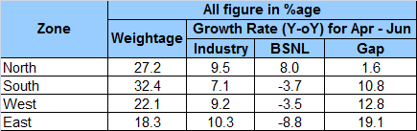

4.2.2 Analysis of North Zone:

- Top three Circles in terms of Weight age: The top three Circles in order of contribution to revenue are UP (East), Rajasthan and UP (West).

- The License area wise growth of the industry vis-à-vis growth of BSNL on Y-o-Y basis (for the period April – June) in the License areas of North zones along with gap in growth rate of BSNL and industry (in the increasing order of gap) is given below :
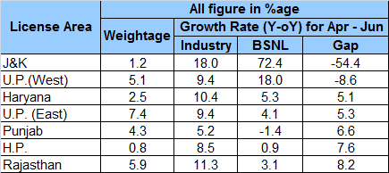

- All circles (except Punjab circle) in North zone which have registered a positive growth in Gross revenue on Y-o-Y basis.

- The top three Circles registering highest growth (Y-o-Y) for the industry is: J&K (18.0%), Rajasthan (11.3%) and Haryana (10.4%). Comparatively, the growth of BSNL in these circles is J&K (72.4%), Rajasthan (3.1%) and Haryana (5.3%).

4.2.3 Analysis of South Zone:
- Top three Circles in terms of Weight age: The top three Circles in order of contribution to revenue are Andhra Pradesh, Tamil Nadu and Karnataka.

- The License area wise growth of the industry vis-à-vis growth of BSNL on Y-o-Y basis (for the period April – June) in the License areas of South zone along with gap in growth rate of BSNL and industry (in the increasing order of gap) is given below :
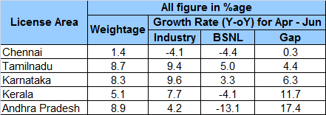

- Tamilnadu & Karnataka circles are the only circles in south zone which have registered a positive growth in Gross revenue on Y-o-Y basis.

- The top three Circles registering highest growth (Y-o-Y) for the industry is: Karnataka (9.6%), Tamilnadu (9.4%) and Kerala (7.7%). Comparatively, the growth of BSNL in these circles is Karnataka (3.3%), Tamilnadu (5.0%) and Kerala (-4.1%).

    - Analysis of West Zone:

- Top three Circles in terms of Weight age: The top three Circles in order of contribution to revenue are Maharashtra, Gujarat and Madhya Pradesh.

- The License area wise growth of the industry vis-à-vis growth of BSNL on Y-o-Y basis (for the period April – June) in the License areas of West zone along with gap in growth rate of BSNL and industry (in the increasing order of gap) is given below :
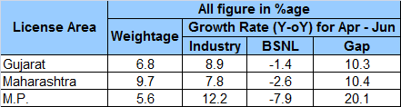

- The top three Circles registering highest growth (Y-o-Y) for the industry is: Madhya Pradesh (12.2%), Gujarat (8.9%) and Maharashtra (7.8%). Comparatively, the growth of BSNL in these circles are Madhya Pradesh (-7.9%), Gujarat (-1.4%) and Maharashtra (-2.6%).

    - Analysis of East Zone:

- Top three Circles in terms of Weight age: The top three Circles in order of contribution to revenue are Bihar, West Bengal and Kolkata.

- The License area wise growth of the industry vis-à-vis growth of BSNL on Y-o-Y basis (for the period April – June) in the License areas of East zone along with gap in growth rate of BSNL and industry (in the increasing order of gap) is given below :
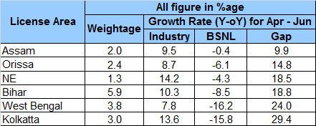

- The top three Circles registering highest growth (Y-o-Y) for the industry is: North East (14.2%), Kolkata (13.6%) and Bihar (10.3%). Comparatively, the growth of BSNL in these circles is North East (-4.3%), Kolkata (-15.8%) and Bihar (-8.5%).

  - Analysis of BSNL’s Revenue growth in Basic and Mobile licence, the details are given in Annexure 3. The salient points are:

- The revenue from BSNL’s Basic license on Y-o-Y basis ( 2012-13 vs 2013-14) for the period April – June has declined from 1,883 crore to 1,726 crore, showing a decline of 8.34% . In the same way revenue from BSNL’s Mobile license on Y-o-Y basis ( 2012-13 vs 2013-14) for the period April – June has increased from 2,400 crore to 2,482crore, making a growth of 3.43%.

- In the Mobile services, South zone is the largest contributor of the revenue has registered a negative growth of 0.35% on Y-0-Y basis (2012-13 vs 2013-14) for the period April – June. In the same period, North Zone & West Zone registered a positive growth of 11.22% & 10.01% respectively.

- In the Basic services, North Zone has registered a positive growth of 2.71% on Y-0-Y basis (2012-13 vs 2013-14) for the period April – June. In the same period, South Zone, West Zone and East zone registered a negative growth of (-8.31%), (-13.40%) and (-14.60%) respectively.

Encl: Annexure-1 to 3.

(J.K. JAIN) AGM (CP&M-1)
To
- CMD, BSNL for information please.
- Dir (CFA)/ Dir(HR)/ Dir(Enterprise)/ Dir(CM)/ Dir(F) for information please.
- ED (CA)/ ED(F)/ ED(CN) for information for information please.
- All CGMs (Telecom Circles) / (Metro District) for information and further action please. (Through Intranet)
- All PGMs / Sr GMs / GMs of Corporate Office. (Through Intranet)

------------------------------------------------------------------------------------------------------------------------------------------------------------
Regd Office : Bharat Sanchar Bhawan, Harish Chandra Mathur Lane, Janpath, New Delhi-1 Website: www.bsnl.co.in

